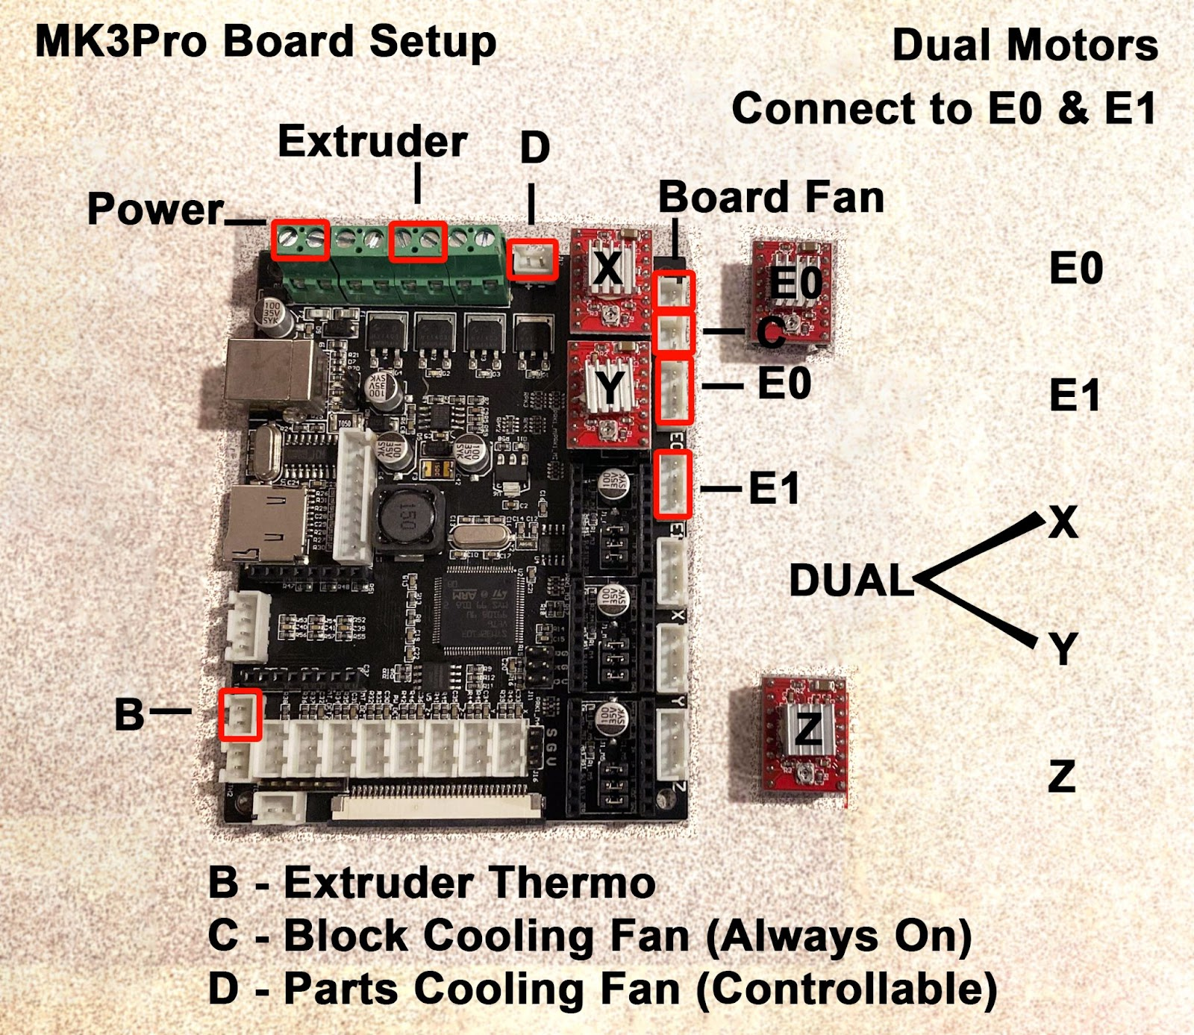

TB/PC0:G 3V3

TH2:G 3V3

B:TH1

BED HTR  
PA0  
VCC RTN

HEATER_1   
PB0  
VCC RTN

FAN  
PB1  
 RTN +